Design Document
Version No.: 1.0
Date: 8th July 2015

Project Team Name: GOOGLE

Revision History
Version No. | Date | Prepared by / Modified by | Significant Changes

Glossary
Abbreviation | Description
MI | Material Indent.
PO | Purchase Order.
SIN | Stores Inward Note.
MIN | Material Issue Note.

Table of Contents

1 Introduction 4
1.1 Purpose 4
1.2 Scope of the System 4
2 Software Design 4
2.1 Data input screen design 4
2.2 Data Flow Diagram 4
2.3 Database and Table Design 4
2.4 Structure Chart 4
2.5 Report Layout And Description 5
3 Appendix A – Error and Informative Messages 5

Introduction

Purpose
Reputation of a company is one of the pioneers for establishing a good customer-supplier relationship. Nowadays, companies strive for maximum Customer Satisfaction by fulfilling their requirements within the stipulated time along with maintaining the quality of products. Hence, the main aim for the development of this software is to monitor the stock inventories of different stores for the purpose of maintaining a healthy relationship between retail store, central store, supplier and customers.

The communication gap between Retail Store, Central Store and Suppliers leads towards the decay in the efficiency of the company. The customers have to wait for a long time to receive their orders may be due to the lack of availability of items in the retail or central store. Hence, an Inventory Management System can be used to catalyze the process of “Order-Receive-Issue-Reorder”, thereby reducing manual efforts leading to lesser human errors.

So, implementation of this software can revolutionize the way of functioning of the Inventory Management System providing a reliable solution to the problem of Inventory control.

Scope of the System
The scope of this software is not limited to a particular constraint but it diversifies exponentially with the exploration of more and more functionality.
Hence, by considering the overall functionality of this software, its scope can be summarized as a system to fulfill the purchase request made by either the customers, regarding the inventory items to a retail store or a request made by the retail store to the central store for supplying products and even offering the fulfillment of Central Store inventories by the Suppliers in case the stock reaches a threshold value also called as Minimum Stock Level (in this scenario) which determines the minimum number of stock which should to be available in a particular store before processing any further requests. This is done to prevent the unavailability of inventory to the customer or failure to process the purchase request, hence providing a more efficient service.
Functionalities of this software can be categorized as follows:
- Raising a Material Indent (MI) by the Retail Store Manager which comprises of details such as Material Indent Number (MIN), Material Indent (MI) Date, Item Code, Item Description, Quantity of item required, Cost of per unit item, Required Date , Status of the item whether accepted or rejected, Requesting authority.
- Material Indent raised by the Retail Store Manager is accepted or rejected by the Head Central Store.
- If the MI is being accepted and the Central Store has sufficient quantity of inventory, then the stock is released to the Retail Store by the Central Store Manager and the database is updated.
- If the MI is rejected, then the Retail Store is notified about the request being rejected by the Head Central Store.
- If the MI is accepted but the Central Store does not sufficient stocks to fulfill future orders or in case the stock reaches Minimum Stock Level, then in this case, a purchase order (PO) is raised by the Central Store Manager to the Supplier requesting a specified quantity.
- The supplier then fulfills the purchase request of the Central Store.
- After the stock is successfully received, the database is updated for the particular Stock Inward Number.
- After the successful generation of SIN, the Quality Manager either accepts or rejects or partially accepts the Purchase Order and the billing is done according to the items issued, accepted or rejected.
The above process takes place periodically monitoring the stock level of the stores.
The overall functionality of the system can be categorized mainly as:
- Raising a Material Indent (MI) by the retail store manager to the head central store.
- Acceptance or rejection of MI by the Head central store.
- PO rose by Central Store to the Supplier in case the stock level reaches below Minimum Stock Level.
- SIN generated after successful receiving the stocks from the supplier is monitored by the Quality Manager and then accordingly classified as accepted, rejected or partially accepted.
- The amount is calculated on the basis of the quantity of items being accepted, rejected and issued. This is reflected in the database.
Hence, it can be concluded from the above sequence of processing that the work flow is well structured and hence results in increased efficiency thereby reducing the time of processing as compared to manual processing of the same process of “Order-Receive-Issue-Reorder”.

Software Design

Data input screen design
2.1.1 Login Input Screen

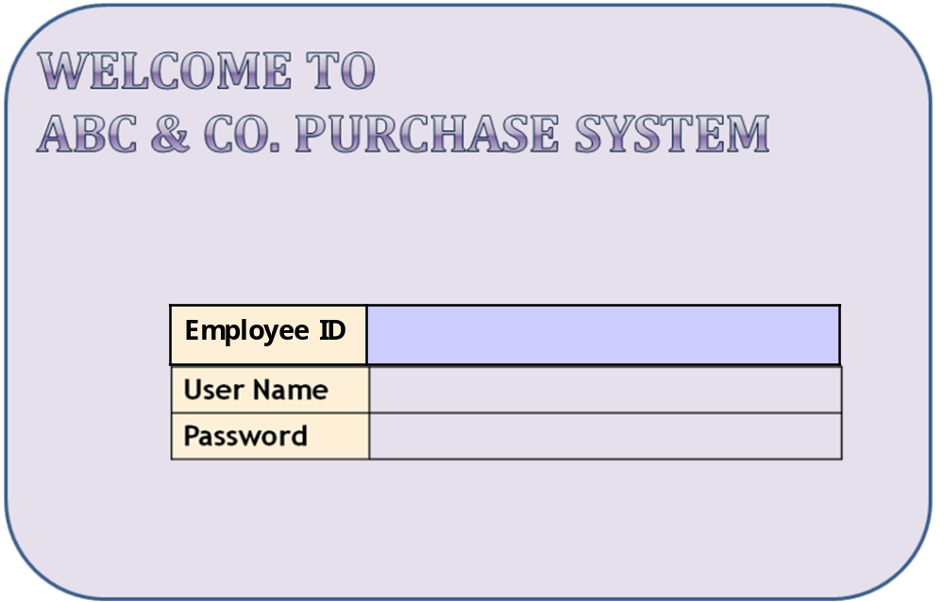

Data Flow Diagram

Data Flow for Login Function

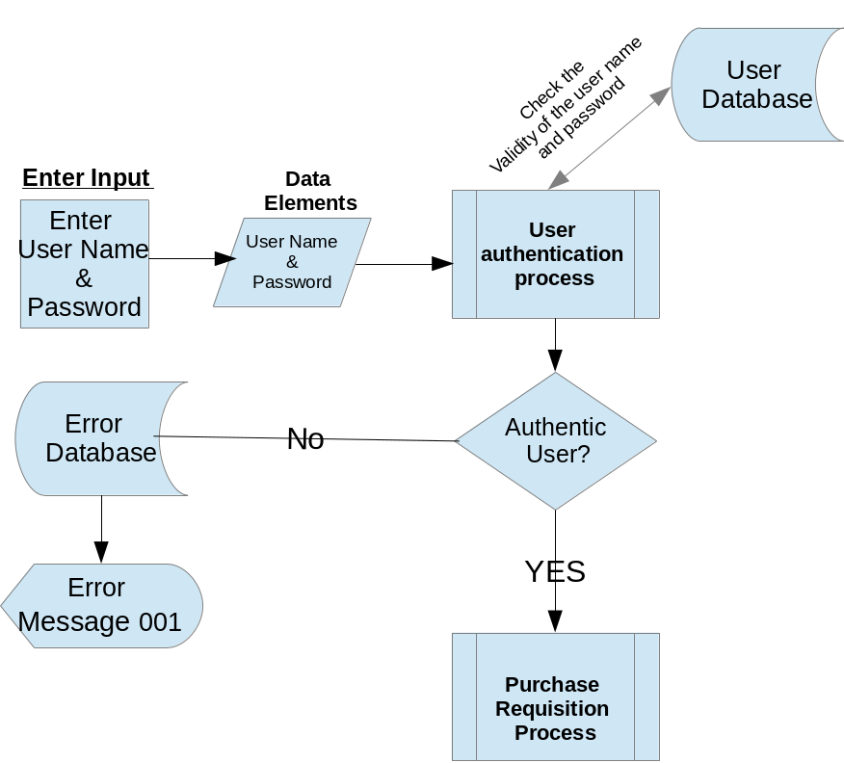

Data Flow diagram for Order raised by Retail Store Manager
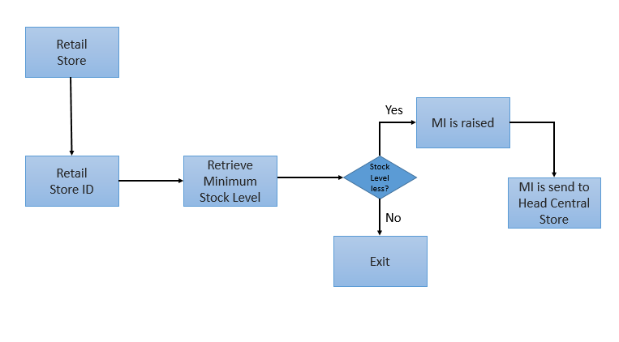

Data Flow diagram for Order processing and dispatch by Central Store
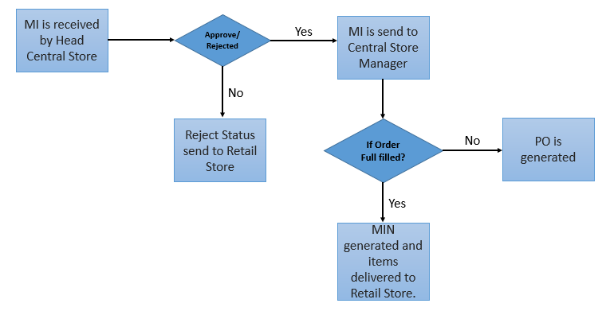

Data Flow diagram for Central Store Manager placing order to supplier
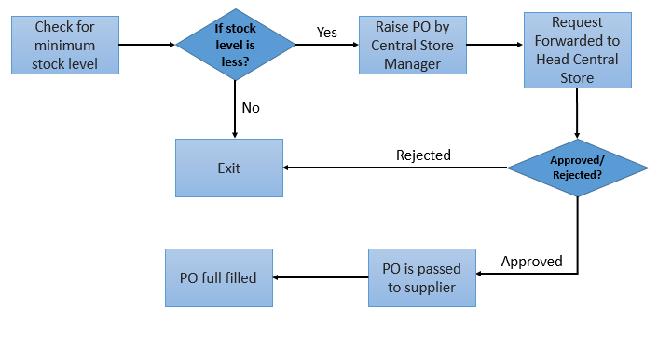

Data Flow diagram for Supplier dispatch to Central Store
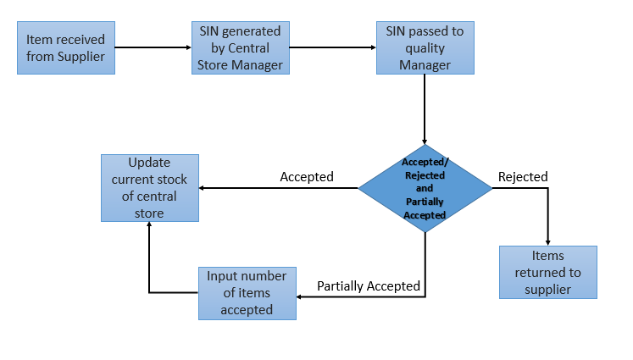

Database and Table Design

Refer diagram for SESCON Database Structure.jpg Database and Table Design.

Structure Chart
Refer diagram Structure Flow Diagram.jpg for the structure diagram.

Report Layout and Description

Purchase Request

Item Code
Item Description
Quantity Required
Required On
001
Watches
20
15-07-2015
Approved
Rejected
Requested By
PR Raised By
PR Date
PR App./Rej By
Maintenance
Department
Mr. Arjun
27-07-2015
Mr. Abhay
Purchase Requisition No.
PR-001
ABC & CO
Purchase Requisition Form

ABC & Co. Purchase Order
Purchase Order No. |  | PO-001
Purchase Order Dt. |  | 09-Jul-15
To
M/s XYZ Trading Company
#123,Ram Nagar
Coimbatore
Item Code | Item Description |  |  | Quantity Reqd | UOM | Required On | Rate(Rs.) | Value(Rs.)
001 | Watches |  |  | 20 | Nos. | 15/7/2015 | 100 | 2000
Approved |  |  |  |  | PO raised by |  |  | PO Approved By
Rejected |  |  |  |  | Mr. Abhay |  |  | Head-Central Store

ABC & Co. Store Receipt Note(SIN)
Purchase Order No. | PO-001 | MI No. |  | SIN No. | SIN-001
Purchase Order Dt. | 09-Jul-15 | MI Date |  | SIN Date | 15/07/2015
Item Code | Item Description | PO Quantity | UOM | Received Qty | Received On
001 | Watches | 20 | Nos. | 20 | 17/07/2105
Quality Inspection By | Qty Inspected | Qty Accepted | Qty Rejected | Quality Reference | SIN Prepared By
 | 20 | 18 | 2 | QR-001
Mr. Arjun |  |  |  |  | Manager-Central Stores
Reason for rejection:
2 no. of the watches are broken

ABC & Co. Material Issue Note(MIN)
MI No. | MI-001 |  |  | MIN No. |  | Opening Stock
MI Date | 16/07/2015 |  |  | MIN Date |  | 50
Item Code | Item Description | MI Qty | Issued Qty | UOM | Issued On | Pending MI Qty
001 | Watches | 25 | 20 | Nos. | 12/07/2015 | 5
Item issued To | Closing Stock | Remarks
Mr. Arjun | 7 | Remarks

Appendix A – Error and Informative Messages
Table of error code / text for the batch processes
Error Code | Error Text
001 | Unauthorized user
002 | User Name or Password wrong

